**Documentation of Courier Services**

**Our Project and Group Members:**

**Project Name**: Courier Management System.

**Faculty:**  Sir Mohsin.

**Co-Ordinator:**  Miss Mahwish.

**Group Members**:

* Usman Ahmed
* Haider Faraz
* Sana Yousuf

**Time Duration:**

*5-February-2023*

*To*

*7-March-2023*

**Table of Contents:**

* Introduction
* Proposed Scenario
* System Module
* Module Description

**Introduction:**

*Courier management system is currently handled manually by the organization and facing various*

*challenges in maintaining records and providing information to its customers. Tracking and handling*

*of couriers is becoming tedious for the organization.*

**Proposed Solution:**

*Courier management system is a management software designed by considering various factors in*

*courier billing system. The proposed web app will help to manage customer information, package*

*details, generate reports, app billing. Courier management web application will be a comprehensive*

*and complete application will be able to manage all its operations and also the tracking and manage*

*delivery info all registered consignments or packages, manage customer related information. The*

*web app provides necessary info of status. Admin will update the details of both sender and receiver*

*include status of booked package or consignment. User can track the courier through online site.*

**System Modules:**

**Admin:**

* *Login*
* *New courier*
* *View all courier details*
* *Send SMS – From to*
* *Send delivery SMS*
* *Update/ delete courier*
* *Create agent*
* *Manage agent*
* *Manage customer details*
* *Status count*
* *Download report for shipment*

**Agent:**

* *Login*
* *New courier*
* *View all courier details*
* *Send SMS From to*
* *Send delivery SMS*
* *Status of branch*
* *Download report from branch*

**User:**

* *Register*
* *Login*
* *Track consignment number*
* *View status*
* *Print status*

**Module Description**

**Admin Login**

o Admin will have his/her own login details (username, password) to access the

system

**Create Bill – Admin , Agent**

o Admin can create a Courier Bill after logging in. Bills contain the details of sender,

receiver, courier type, delivery date and Courier Company.

**Update bill– Admin , Agent**

o They can also update the Bill with the entries and if there is any modification. Agent

can view the list of details of his location only.

**Manage Customer details**

o Admin can manage all the Customer Details in a separate and secured Database

**Reporting**

o Reports of all the Bill can be viewed by the admin of the system

**Logout**

o At last they can logout if they have done with their actions on the database.

**Dashboard Requirements**

**Admin and Agent Dashboard**

o Status Counts

* View total status count for shipment, in progress, delivered.
* Admin will view all location status counts.
* Agent can view only from or to location of his branch.

o Add Shipment

* New Courier

o Manage Shipment

o Print Shipment

* User can print tracking details

o Download Report (XLSX)

* Date Wise
* City Wise

**Admin Dashboard**

o Add Agent

* Can view only “from or to” location

o Create Agent city wise login

o Manage Customer

* Search

**User Login**

o Track Shipment

* User can search using consignment tracking details

o Shipment status

o Print

* User can print tracking details

**LOGIN AND SIGNUP PATTERN**

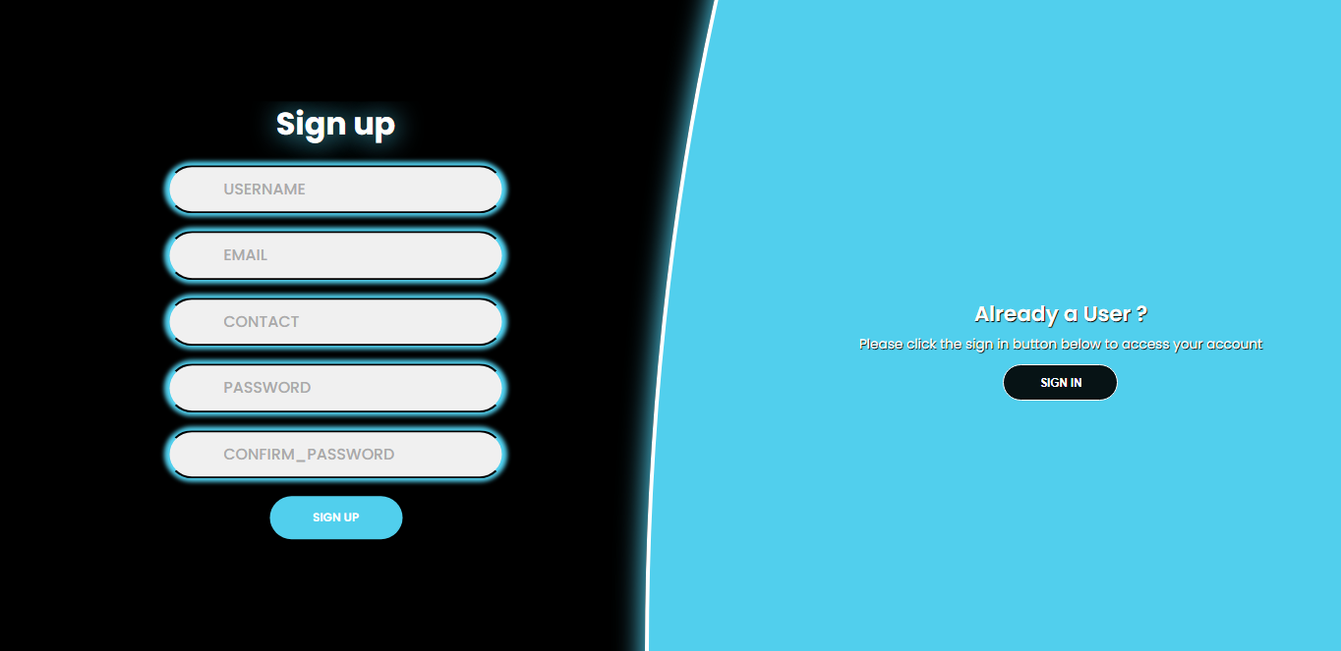

* **Admin Login:**

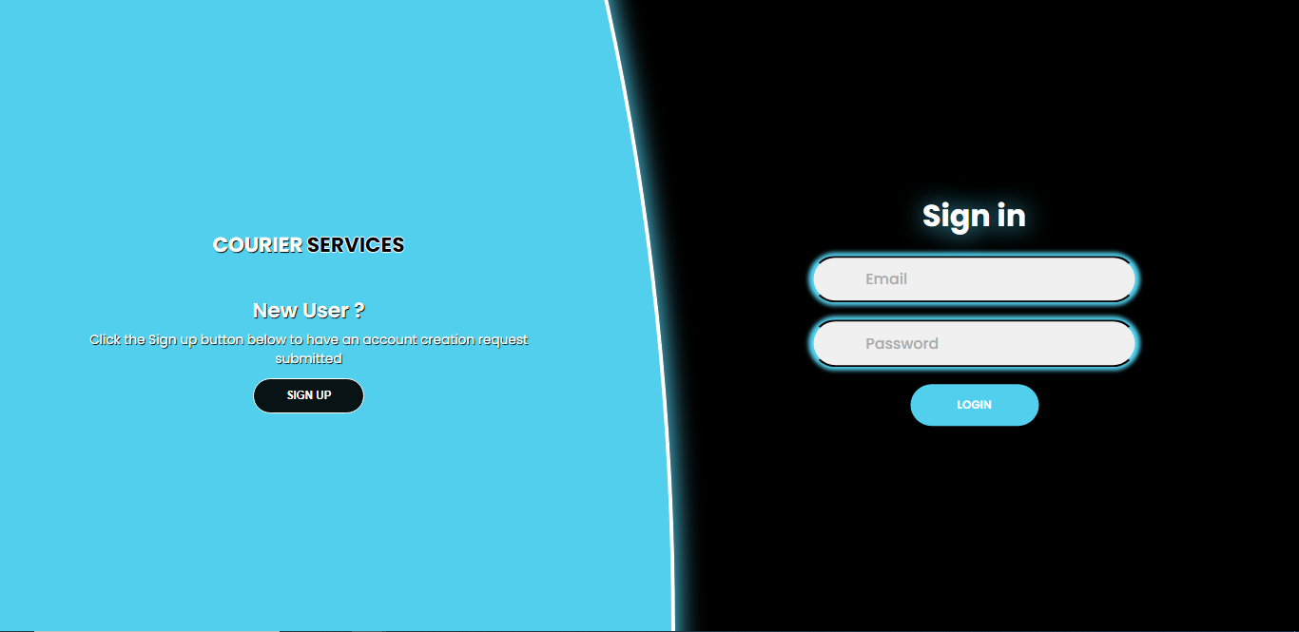

There are three Admin Account logins define below on page no 8.

* **Agent Login:**

Only Admin can create an agent’s account, In order to login an agent’s account he must enter ***(@Cagent.com)*** at the end of his mail.

* **User Login:**

A user can create his own account by entering ***(@Cservice.com)*** at the end of his mail.

**Admin Guide:**

These are our main admin pages

* Dashboard
* Agent
* Create Agent
* View Agent
* Courier
* Create Bill
* Update Bill
* Shipment
* Manage shipment
* View Shipment
* OverAll User
* Report
* Add_Branch
* Status
* Feedback

**How we can login our Admin pages?**

**Ans).** By entering the following emails and passwords we can easily get access to our admin dashboard.

|  |  |
| --- | --- |
| **EMAILS** | **PASSWORD** |
| usman67483@gmail.com | usman123 |
| 8008297@gmail.com | haider123 |
| sanayousuf015@gmail.com | sana123 |

**Admin Dashboard:**

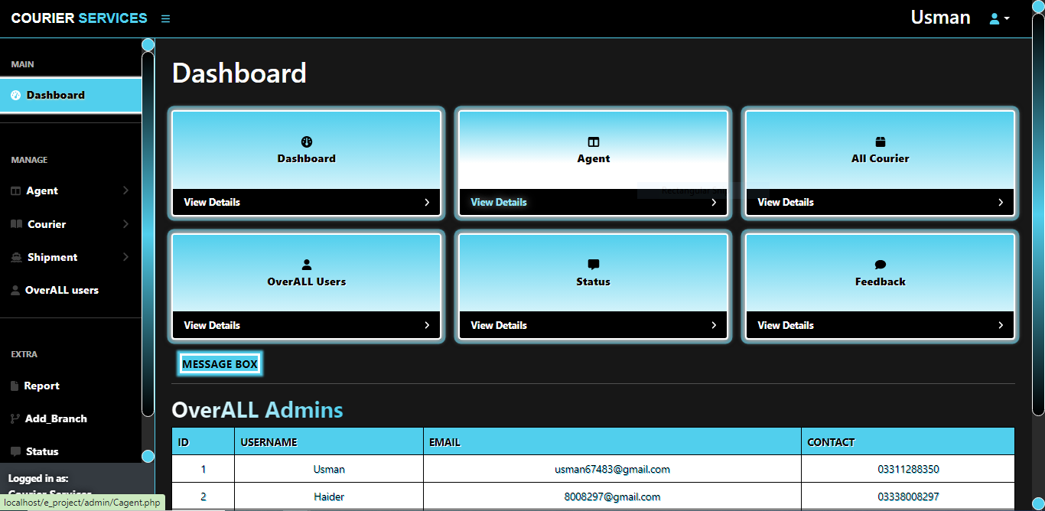

There are six links given in squares on the main page of admin dashboard one of them is the dashboard itself and the other are Agent , ALL Courier , Overall Users , Status , Feedback.

We can also see the Username , Email , Contact on the main page of admin dashboard as well.

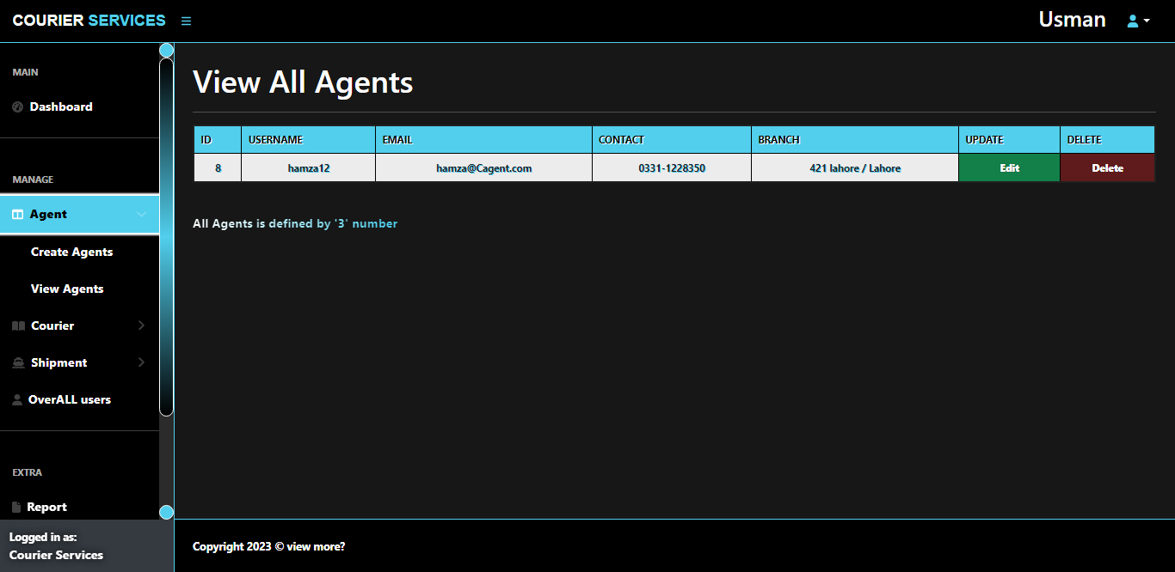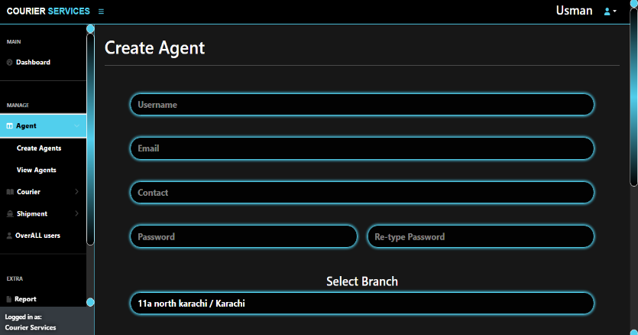**Admin (Agent):**

By clicking on **Agent** we can see other two links which are *Create Agent*, *View Agent*

* **Create Agent:**

The First Image shown in **Admin (Agent)** above is the ***Create agent*** page . Through create Agent page we can appoint in agent according to cities and branches.

* **View Agent:**

The Second Image shown in **Admin (Agent)** above is the ***View agent*** page . Through view Agent page we can see all the agents we have appointed according to cities and branches. The **Admin** can also update and delete an agent.

**Admin Courier:**

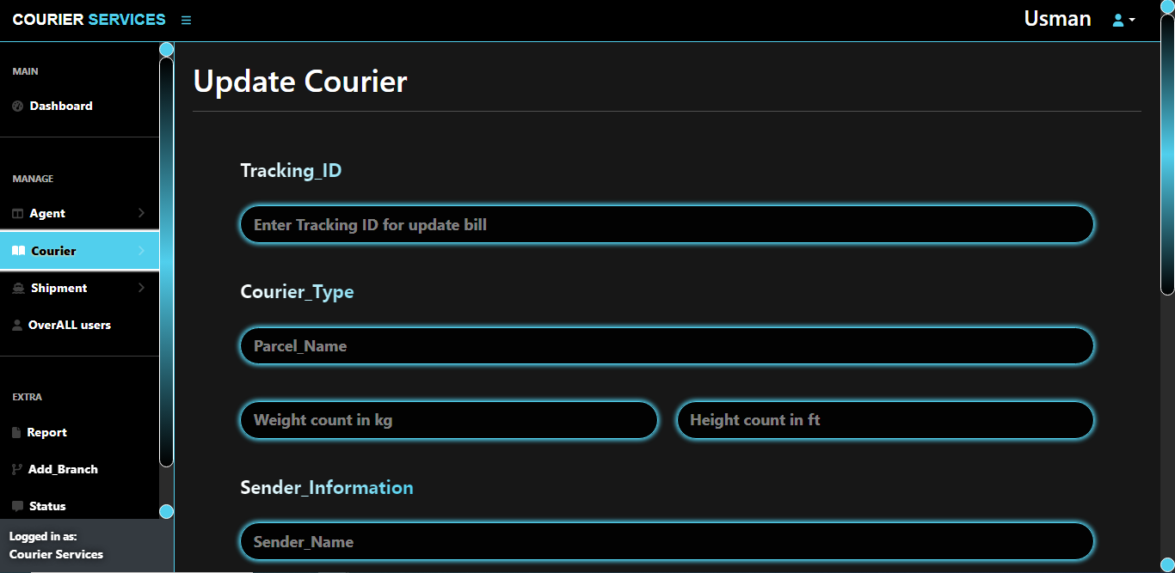

By clicking on **Courier** we can see other two links which are *New Courier*, *Update Courier*.

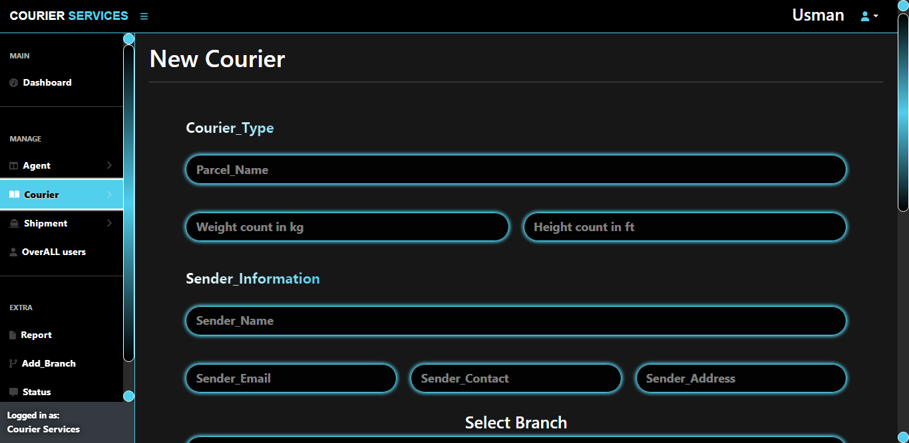

* **New Courier:**

If a user don’t know how to place a courier he can place it by reaching out to the nearest branch by the help of admin.

* **Update Courier:**

If a user gives wrong information about his courier he can update the details by contacting the admin.

**Admin Shipment:**

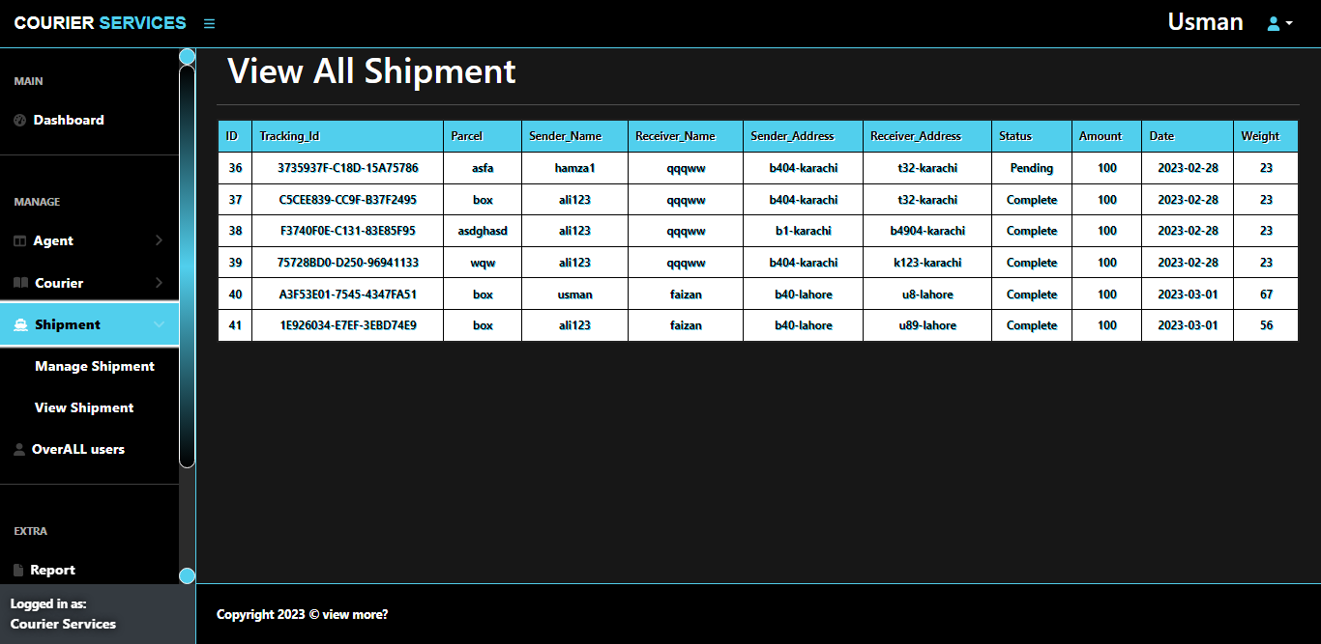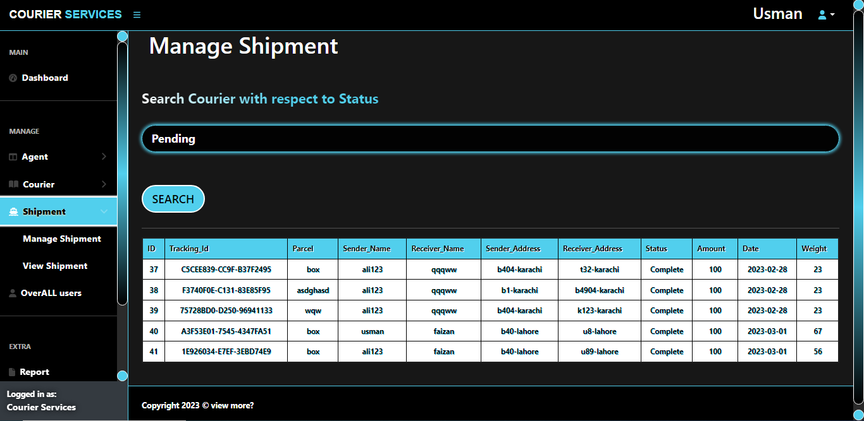

By clicking on **Shipment** we can see other two links which are *Manage Shipment*, *View ALL Shipment*.

* **Manage Shipment:**

In manage shipment admin can view the shipment details of the couriers that have been placed by selecting the status admin wants to see.

* **View ALL Shipment:**

Admin can view all the shipment details.

**Admin (Overall User):**

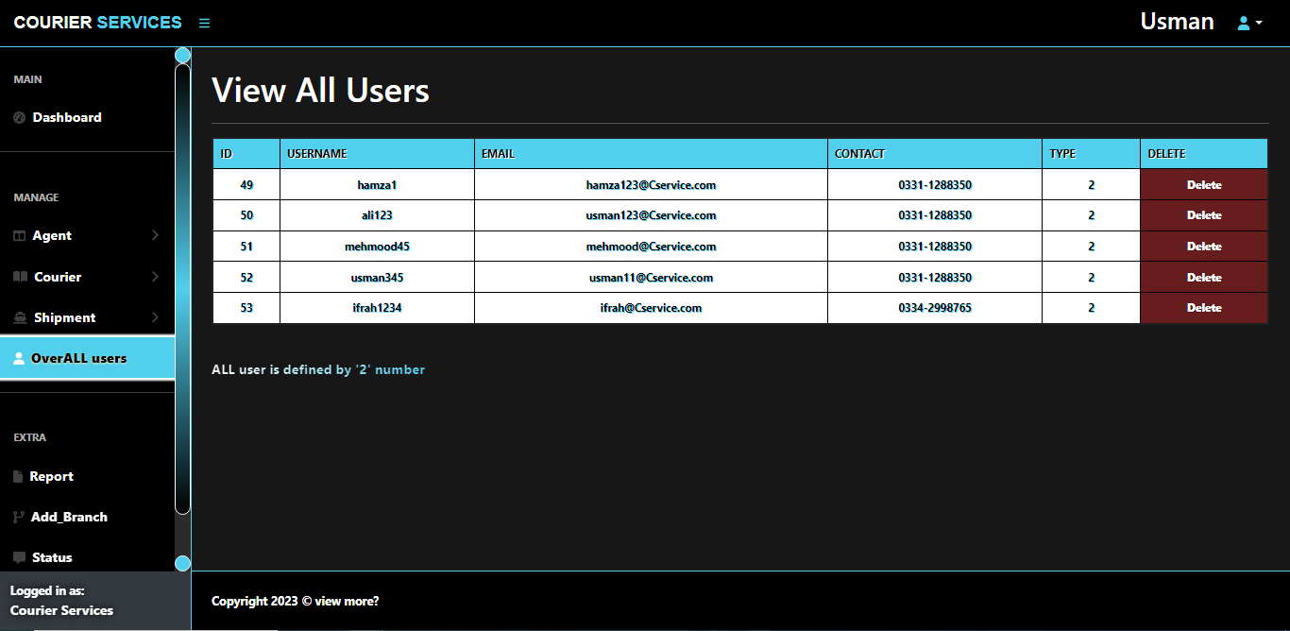

Admin can view all the registered accounts of users and can also delete a user if there is any violation from any user.

**Admin (Report):**

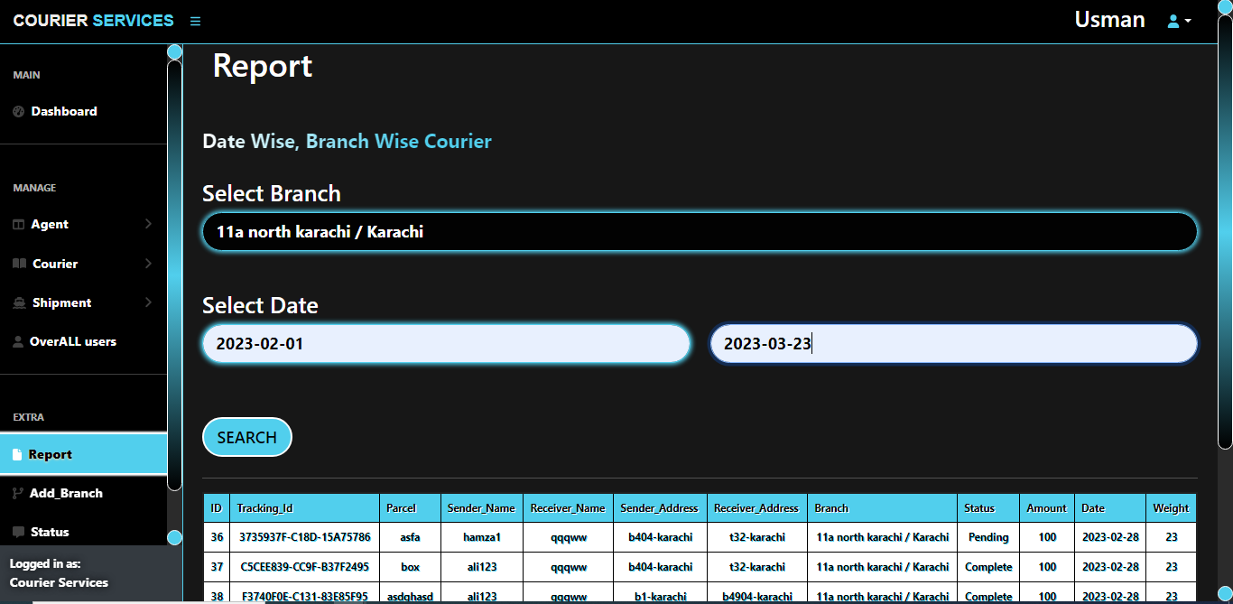

Admin can view the reports of all the shipment details according to the date and branch Admin enters and can also extract the report in an **XLS** document.

**Admin (Add Branch):**

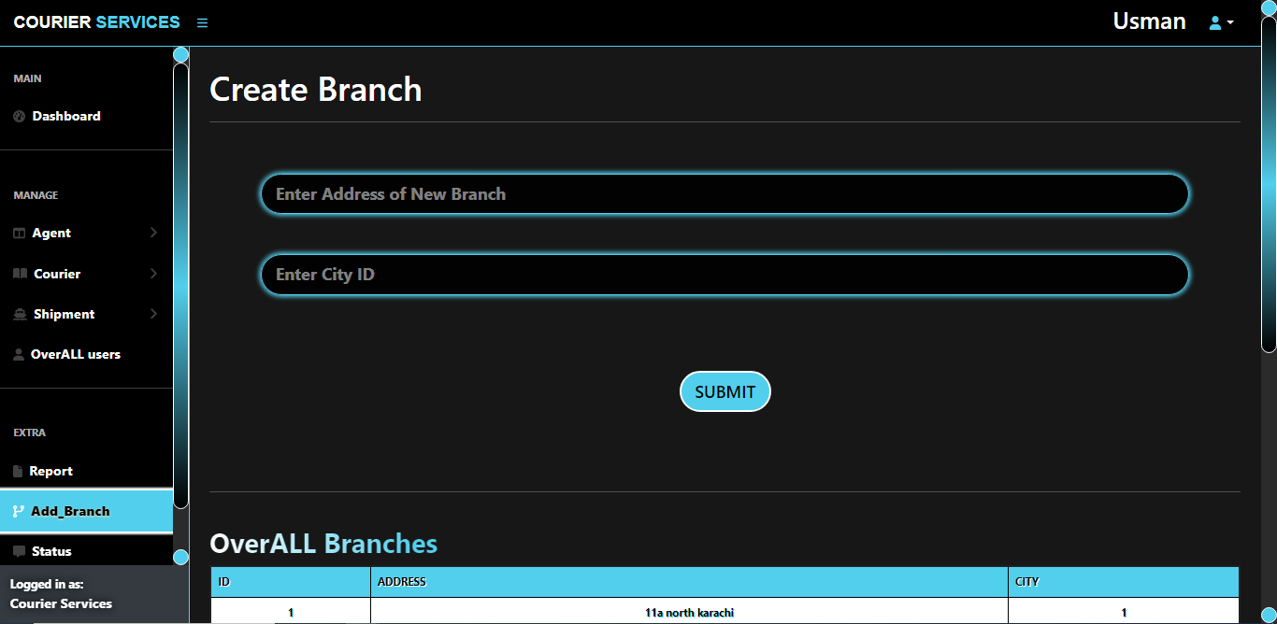

Admin can also create a branch.

**Admin (Status):**

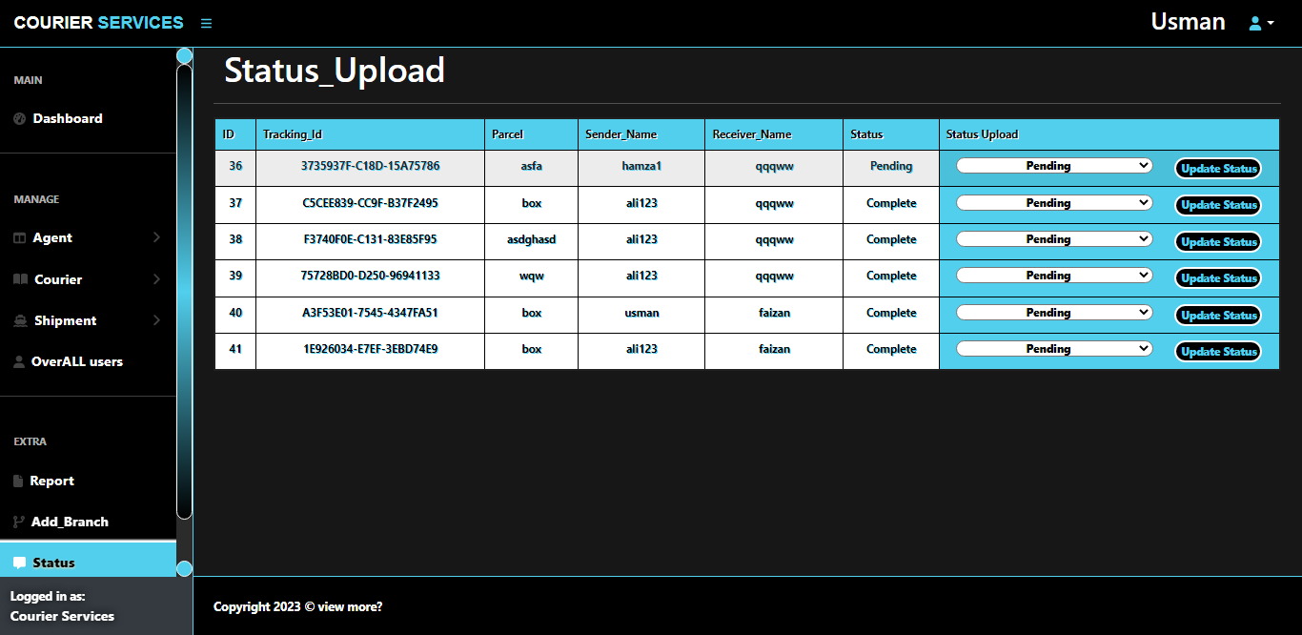

Whenever a new courier is placed admin uploads the status of that courier that it has been on ***pending***, ***(On the way)*** or ***Completed***.

**Admin (Feedback):**

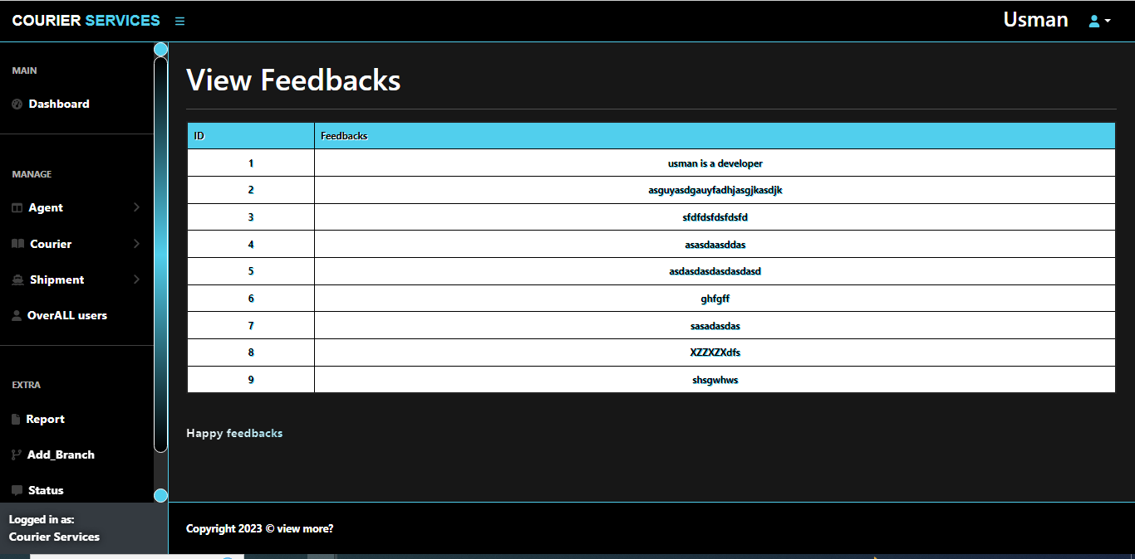

Admin and agent can view all the feedbacks users have given on our services.

**Agent Guide:**

These are our main Agent pages

* Dashboard
* Courier
* Create Bill
* Update Bill
* Shipment
* Manage shipment
* View Shipment
* Report
* Status
* Feedback

**Agent Dashboard:**

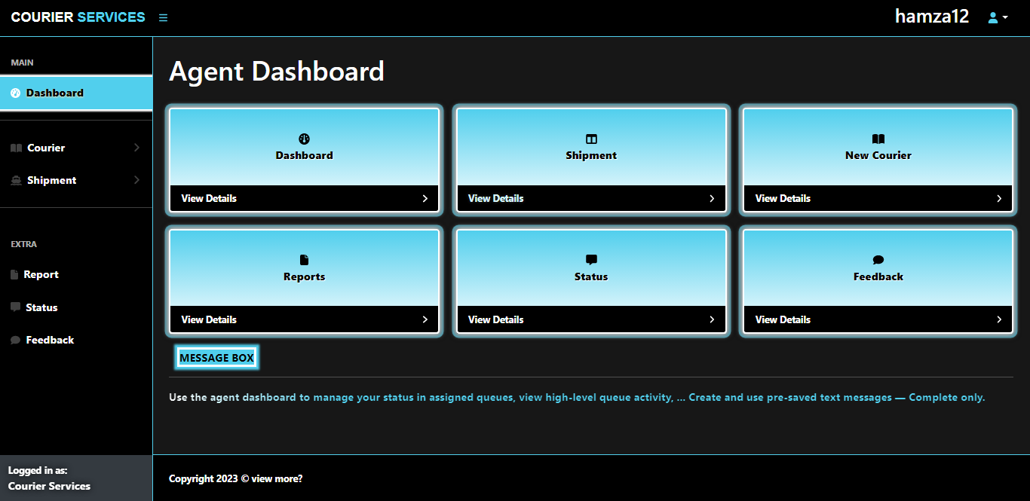

There are six links given in squares on the main page of Agent dashboard one of them is the dashboard itself and the other are Shipment, New Courier, Report, Status, Feedback.

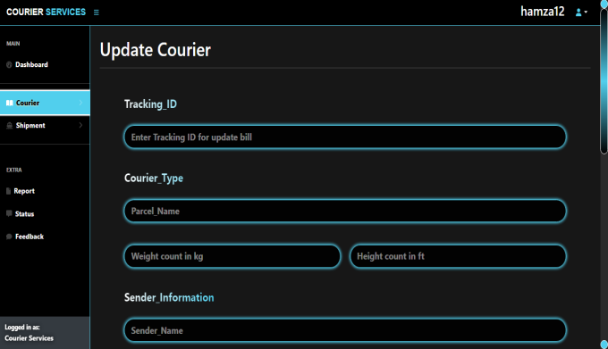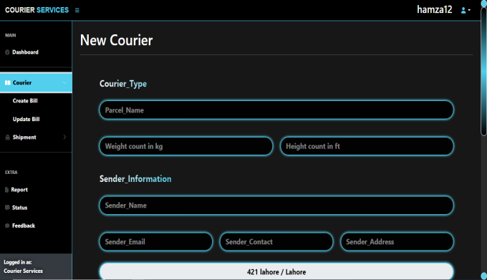**Agent Courier:**

By clicking on **Courier** we can see other two links which are *New Courier*, *Update Courier*.

* **New Courier:**

If a user don’t know how to place a courier he can place it by reaching out to the nearest branch by the help of agent.

* **Update Courier:**

The details of the courier can only be updated on the same branch where the courier has been placed.

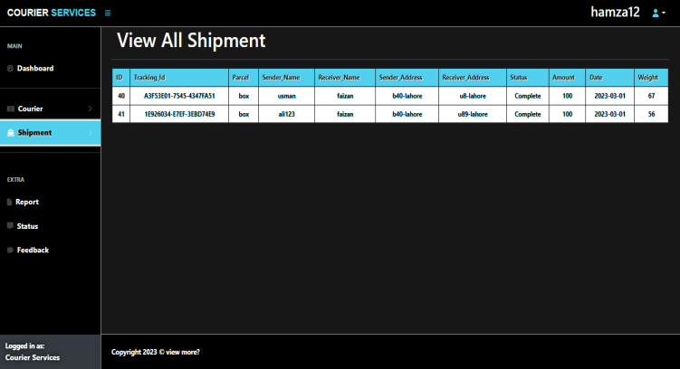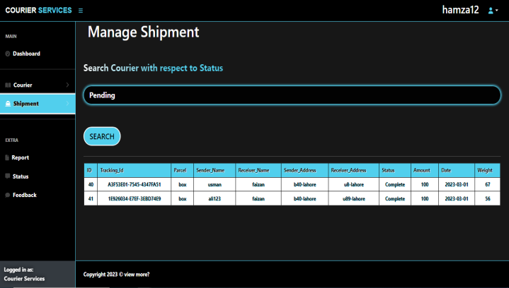**Agent Shipment:**

By clicking on **Shipment** we can see other two links which are *Manage Shipment*, *View ALL Shipment*.

* **Manage Shipment:**

In manage shipment agent can view the shipment details of the couriers that have been placed by selecting the status agent wants to see only of his branch.

* **View ALL Shipment:**

Agent can view all the shipment details of his branch.

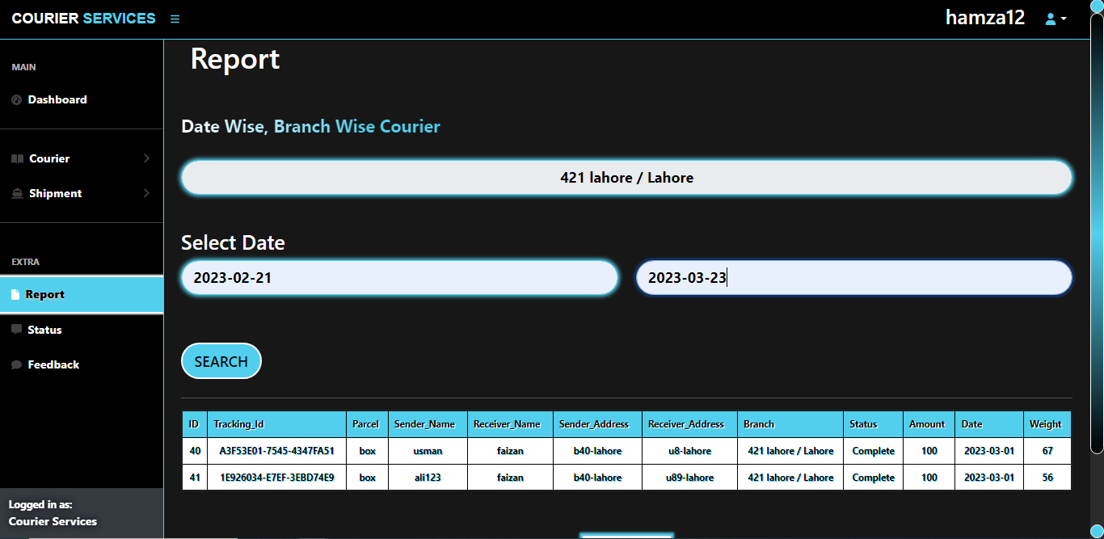**Agent (Report):**

Agent can view the reports of all the shipment details according to the date and his branch Agent enters and can also extract the report in an **XLS** document.

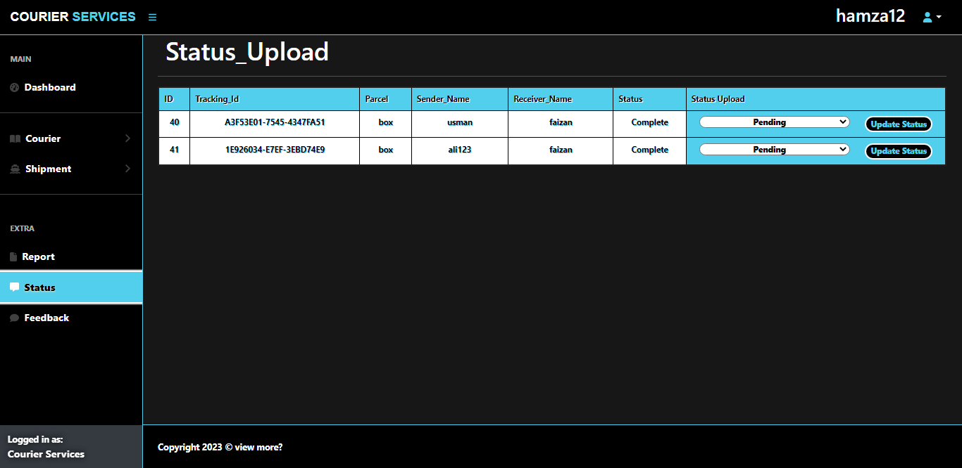**Agent (Status):**

Whenever a new courier is placed agent uploads the status of that courier of his branch that it has been on ***pending***, ***(On the way)*** or ***Completed***.

**User Guide:**

These are our main User pages

* Home
* Add Courier
* About
* Contact
* Tracking

Home

About

Contact

* Message

**User (Home):**



This is our home page as we can see a ***Add Courier*** button by clicking on it. It will lead us directly to the add courier form where we can enter all the necessary requirements to the place of courier, who’s details will be sending to the ***Admin/Agent***.



**User (About, Contact):**

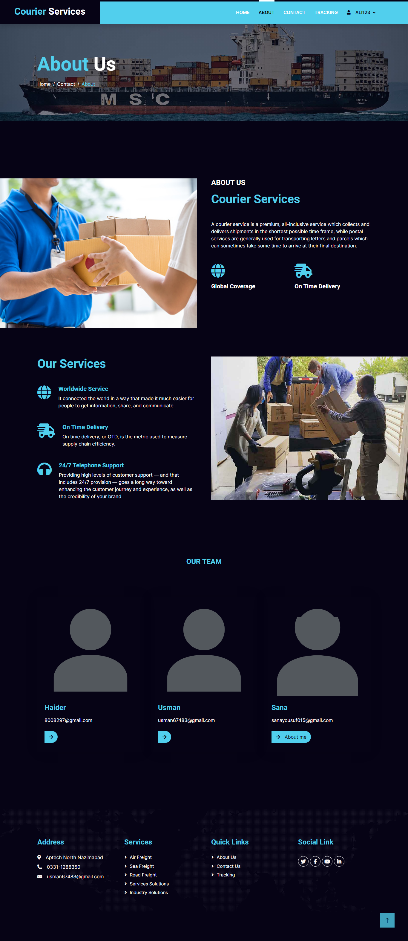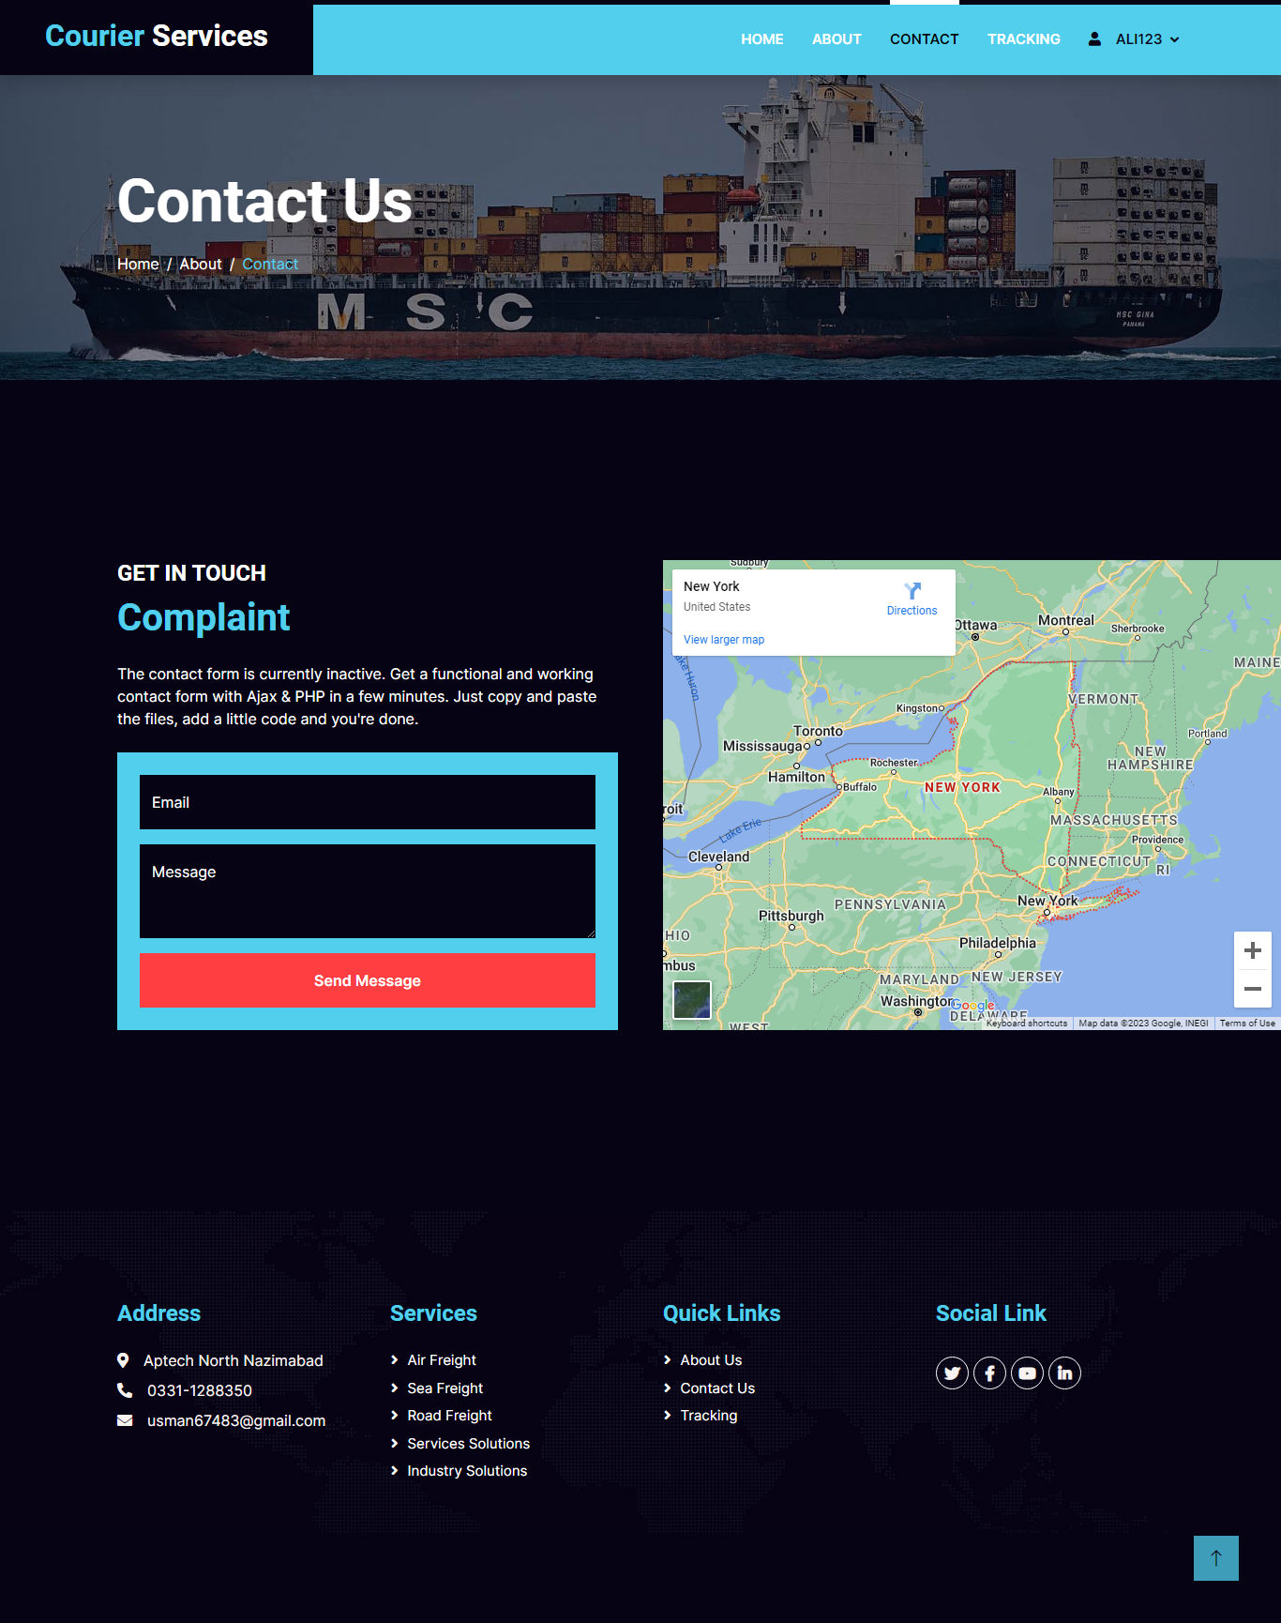

* **About:**

This website is created by our enthusiastic team ***(USMAN, HAIDER AND SANA).***

* **Contact:**

If a user wants to complain or discuss any kind of misunderstanding so the user can contact us through this contact form.

**User (Tracking):**

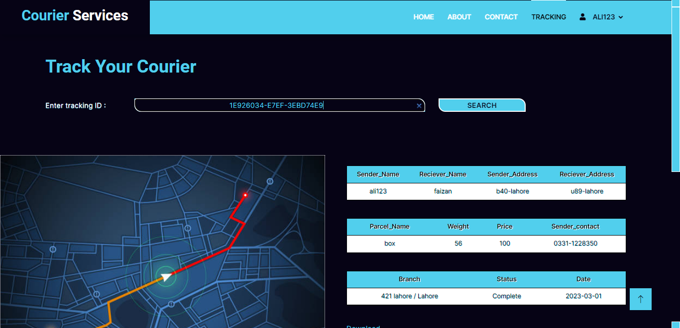

By entering the tracking id that the user gets by placing a courier, the user can view all the details about his courier by entering that tracking id.

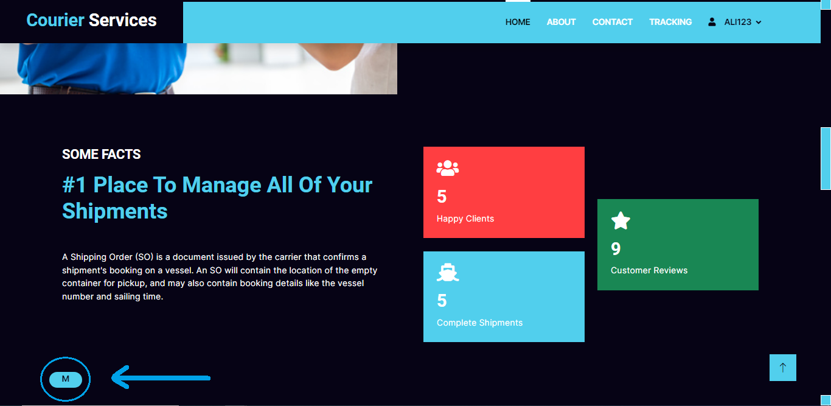**User (Message box):**

By clicking on this message button the user can view all the messages about the status of his courier by the admin.

**Developer Guide:**

**Login/Signup**

**Signup:**

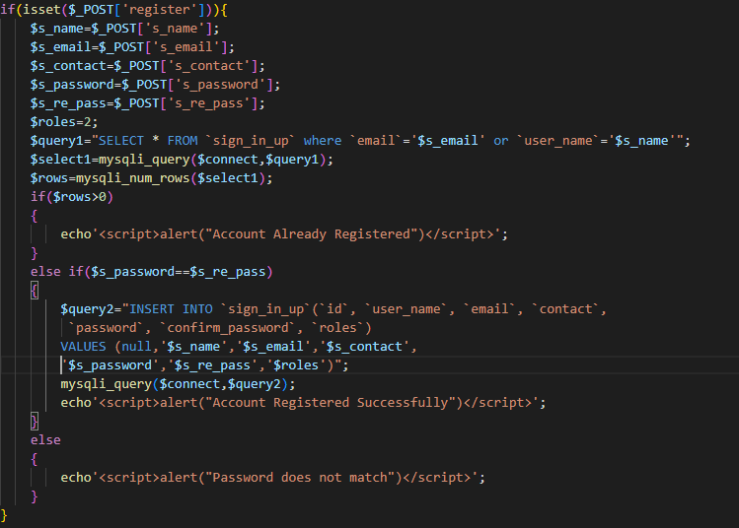

**Login:**

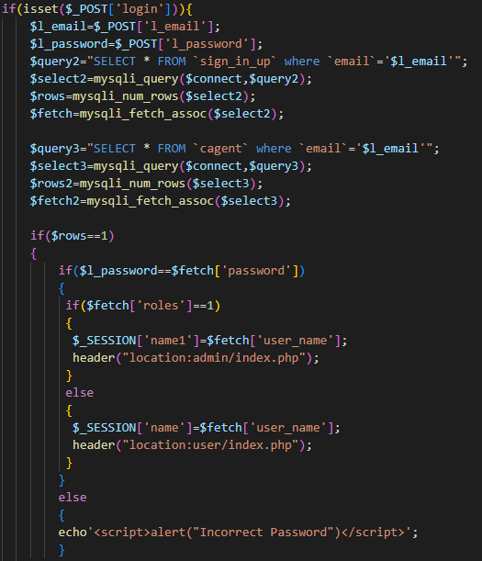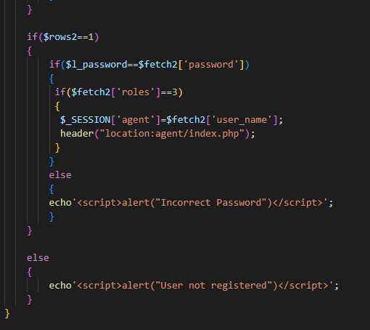

**Developer Guide:**

**Admin and Agent**

**ADMIN AND AGENT(SHIP MANAGEMENT)**

**ADMIN PHP**

if(isset($_POST['submit'])){

    $status=$_POST['status'];

$query="SELECT * FROM `courier_details` where `status`='$status'";

$select=mysqli_query($connect,$query);

}

**AGENT PHP**

$u_name=$_SESSION['agent'];

$query1="SELECT * FROM `cagent` WHERE   user_name='$u_name'";

$con=mysqli_query($connect,$query1);

$fetch=mysqli_fetch_assoc($con);

$b=$fetch['branch'];

if(isset($_POST['submit'])){

    $status=$_POST['status'];

$query="SELECT * FROM `courier_details` where `status`='$status' && `branch`='$b'";

$select=mysqli_query($connect,$query);

}

**BODY WORK(AGENT AND ADMIN)**

     <form method='POST' >

        <select name='status' class='form-control form-control-lg fieldAg'>

            <option>Pending</option>

            <option>On the way</option>

            <option>Complete</option>

        </select>

        <br>

        <br>

        <input type="submit" value="Search" name="submit" class="btnnn btn-lg">

</form>

<hr>

                <table class="table1 dataTable-table container">

  <thead>

    <tr>

      <th scope="col"class="th">ID</th>

      <th scope="col"class="th">Tracking_Id</th>

      <th scope="col"class="th">Parcel</th>

      <th scope="col"class="th">Sender_Name</th>

      <th scope="col"class="th">Receiver_Name</th>

      <th scope="col"class="th">Sender_Address</th>

      <th scope="col"class="th">Receiver_Address</th>

      <th scope="col"class="th">Status</th>

      <th scope="col"class="th">Amount</th>

      <th scope="col"class="th">Date</th>

      <th scope="col"class="th">Weight</th>

    </tr>

  </thead>

  <?php

  if(isset($_POST['submit'])){

  while($row=mysqli_fetch_assoc($select))

  {

      echo '

      <tbody>

      <tr>

        <td>'.$row['id'].'</td>

        <td>'.$row['tracking_id'].'</td>

        <td>'.$row['parcel'].'</td>

        <td>'.$row['sender_name'].'</td>

        <td>'.$row['reciever_name'].'</td>

        <td>'.$row['sender_address'].'</td>

        <td>'.$row['reciever_address'].'</td>

        <td>'.$row['status'].'</td>

        <td>'.$row['amount'].'</td>

        <td>'.$row['date'].'</td>

        <td>'.$row['weight'].'</td>

      </tr>';

  }

}

  ?>

</tbody>

</table>

**ADMIN AND AGENT(REPORT)**

**ADMIN PHP**

$query="SELECT A.b_address , B.name from branch as A inner join city as B where A.b_city=B.id";

$con=mysqli_query($connect,$query);

if(isset($_POST['submit'])){

    $branch=$_POST['branch'];

    $sdate=$_POST['sdate'];

    $rdate=$_POST['rdate'];

    $_SESSION['b']=$branch;

    $_SESSION['sd']=$sdate;

    $_SESSION['rd']=$rdate;

$query="SELECT * FROM `courier_details` WHERE `date`>='$sdate' && `date`<='$rdate' && `branch`='$branch'";

$select=mysqli_query($connect,$query);

}

**AGENT PHP**

$u_name=$_SESSION['agent'];

$query1="SELECT * FROM `cagent` WHERE   user_name='$u_name'";

$con=mysqli_query($connect,$query1);

$fetch=mysqli_fetch_assoc($con);

$b=$fetch['branch'];

if(isset($_POST['submit'])){

    $branch=$_POST['branch'];

    $sdate=$_POST['sdate'];

    $rdate=$_POST['rdate'];

    $_SESSION['b']=$branch;

    $_SESSION['sd']=$sdate;

    $_SESSION['rd']=$rdate;

$query="SELECT * FROM `courier_details` WHERE `date`>='$sdate' && `date`<='$rdate' && `branch`='$branch';";

$select=mysqli_query($connect,$query);

}

**BODY WORK(AGENT AND ADMIN)**

   <form method='POST' >

                <div class="row">

                <div class="col-md-12 mb-4">

                <div class="form-outline">

                    <h3>Select Branch</h3>

                <select name="branch" class="form-control form-control-lg fieldAg" id="name" placeholder="branch" required>

                    <optgroup label="SELECT BRANCH">

                <?php

               while($row=mysqli_fetch_assoc($con))

               {

                 echo "<option>" . $row['b_address']." / ".$row['name'] .'<i class="fas fa-angle-down"></i>'. "</option>" ;

             }

                ?>

                     </optgroup>

                </select>

                  </div>

                </div>

              </div>

              <br>

              <h3>Select Date</h3>

              <div class="row">

                <div class="col-md-6 mb-4 pb-2">

                  <div class="form-outline">

                    <input type="text" name="sdate" pattern="[0-9]{4}-[0-9]{2}-[0-9]{2}" class="form-control form-control-lg fieldAg" placeholder="Start date: _ _ _ _ - _ _ - _ _" title="year-month-date e.g 2023-01-09" required>

                  </div>

<br>

                </div>

                <div class="col-md-6 mb-4 pb-2">

                  <div class="form-outline">

                    <input type="text" name="rdate" pattern="[0-9]{4}-[0-9]{2}-[0-9]{2}"  class="form-control form-control-lg fieldAg" placeholder="End date: _ _ _ _ - _ _ - _ _" title="year-month-date e.g 2023-01-09" required>

                  </div>

                </div>

              </div>

        <input type="submit" value="Search" name="submit" class="btnnn btn-lg">

</form>

<hr>

                <table class="table1 dataTable-table container">

  <thead>

    <tr>

      <th scope="col"class="th">ID</th>

      <th scope="col"class="th">Tracking_Id</th>

      <th scope="col"class="th">Parcel</th>

      <th scope="col"class="th">Sender_Name</th>

      <th scope="col"class="th">Receiver_Name</th>

      <th scope="col"class="th">Sender_Address</th>

      <th scope="col"class="th">Receiver_Address</th>

      <th scope="col"class="th">Branch</th>

      <th scope="col"class="th">Status</th>

      <th scope="col"class="th">Amount</th>

      <th scope="col"class="th">Date</th>

      <th scope="col"class="th">Weight</th>

    </tr>

  </thead>

  <?php

  if(isset($_POST['submit'])){

  while($row=mysqli_fetch_assoc($select))

  {

      echo '

      <tbody>

      <tr>

        <td>'.$row['id'].'</td>

        <td>'.$row['tracking_id'].'</td>

        <td>'.$row['parcel'].'</td>

        <td>'.$row['sender_name'].'</td>

        <td>'.$row['reciever_name'].'</td>

        <td>'.$row['sender_address'].'</td>

        <td>'.$row['reciever_address'].'</td>

        <td>'.$row['branch'].'</td>

        <td>'.$row['status'].'</td>

        <td>'.$row['amount'].'</td>

        <td>'.$row['date'].'</td>

        <td>'.$row['weight'].'</td>

</tr>';

  }

}

  ?>

</tbody>

</table>

**ADMIN AND AGENT(STATUS)**

**ADMIN PHP**

$query="SELECT * FROM `courier_details`";

$select=mysqli_query($connect,$query);

**AGENT PHP**

$u_name=$_SESSION['agent'];

$query1="SELECT * FROM `cagent` WHERE   user_name='$u_name'";

$con=mysqli_query($connect,$query1);

$fetch=mysqli_fetch_assoc($con);

$b=$fetch['branch'];

$query="SELECT * FROM `courier_details` where `branch`='$b'";

$select=mysqli_query($connect,$query);

**BODY WORK(AGENT AND ADMIN)**

                <table class="table1 dataTable-table container">

  <thead>

    <tr>

      <th scope="col"class="th">ID</th>

      <th scope="col"class="th">Tracking_Id</th>

      <th scope="col"class="th">Parcel</th>

      <th scope="col"class="th">Sender_Name</th>

      <th scope="col"class="th">Receiver_Name</th>

      <th scope="col"class="th">Status</th>

      <th scope="col"class="th">Status Upload</th>

    </tr>

  </thead>

  <?php

  while($row=mysqli_fetch_assoc($select))

{

      echo '

      <tbody>

      <tr>

        <td>'.$row['id'].'</td>

        <td>'.$row['tracking_id'].'</td>

        <td>'.$row['parcel'].'</td>

        <td>'.$row['sender_name'].'</td>

        <td>'.$row['reciever_name'].'</td>

        <td>'.$row['status'].'</td>

        <td class="mtd">'."

     <div class='container-fluid'>

     <div class='row'>

     <div class='col-sm-8'>

        <form action='stupdate.php? id=$row[id]' method='POST' >

        <select name='status' class='form_status'>

            <option>Pending</option>

            <option>On the way</option>

            <option>Complete</option>

            <option>Wrong Info</option>

        </select>

        </div>

        <div class='col-sm-4'>

        <input type='submit' value='Update Status' name='submit' class='form_submit'>

                </form>"."</td>

      </tr>

      </div></div></div>

      ";

  }

  ?>

</tbody>

</table>

**BODY WORK(AGENT AND ADMIN)(STATUS UPDATE)**

<?php

include 'connection.php';

$id=$_GET["id"];

if(isset($_POST['submit']))

{

    $status=$_POST['status'];

$query="UPDATE `courier_details` SET `status`='$status' where `id`='$id'";

    mysqli_query($connect,$query);

    header("location:status.php");

    if($status=='Wrong Info')

    {

        $query2="DELETE FROM `courier_details` WHERE `id`='$id'";

        mysqli_query($connect,$query2);

    }

}

?>

**Developer Guide:**

**USER**

**Courier Type , Sender , Reciever , Feedback**

$s_name=$_SESSION['senderName'];

$s_email=$_SESSION['email'];

$s_contact=$_SESSION['contact'];

$s_address=$_SESSION['sAddress'];

$s_branch=$_SESSION['branch'];

$parcel_name=$_SESSION['p_name'];

$weight=$_SESSION['weight'];

$height=$_SESSION['height'];

$r_name=$_SESSION['receiverName'];

$r_address=$_SESSION['rAddress'];

$date=date("d/m/Y");

if(isset($_POST['submit4'])){

    $_SESSION['feedback']=$_POST['feedback'];

    $feedback=$_SESSION['feedback'];

}

$price;

if($weight>=20 && $weight<=100)

{

    $price=100;

}

else if($weight>=101 && $weight<=200)

{

    $price=200;

}

else if($weight>=201 && $weight<=300)

{

    $price=300;

}

else if($weight>=301 && $weight<=400)

{

    $price=400;

}

else if($weight>=401 && $weight<=500)

{

    $price=500;

}

else if($weight>=501 && $weight<=700)

{

    $price=800;

}

else if($weight>=701 && $weight<=1000)

{

    $price=1200;

}

else if($weight>1000)

{

    $price=1500;

}

if(isset($_POST['submit4']))

{

$totalbill="INSERT INTO `courier_details`(`id`, `parcel`,

 `sender_name`, `sender_address`, `sender_email`, `reciever_name`,

  `reciever_address`, `branch`, `weight`, `height`, `sender_contact`,

   `tracking_id`, `amount`,`status`) VALUES

    (null,'$parcel_name','$s_name','$s_address',

    '$s_email','$r_name','$r_address','$s_branch','$weight',

    '$height','$s_contact','$tracking','$price','pending')";

    mysqli_query($connect,$totalbill);

$feedback="INSERT INTO `feedback`(`id`, `feedbacks`) VALUES (null,'$feedback')";

mysqli_query($connect,$feedback);

}

**Generate Tracking id**

function GUID()

{

if(function_exists('com_create_guid')===true)

{

    return trim(com_create_guid(),"{}");

}

   return sprintf("%04X%04X-%04X-%04X%04X",

   mt_rand(0,65356),mt_rand(0,65356),mt_rand(30000,60000)

   ,mt_rand(0,65356),mt_rand(0,65356));

}

$tracking=GUID();

**TRACKING**

**PHP**

if(isset($_POST['submit']))

{

    $n=$_SESSION['name'];

    $search=$_POST['search'];

    $_SESSION['s']=$search;

    $query="SELECT * FROM `courier_details` WHERE `tracking_id`='$search' && `sender_name`='$n'";

    $con=mysqli_query($connect,$query);

    $con1=mysqli_query($connect,$query);

    $con2=mysqli_query($connect,$query);

}

**BODY**

<form method="post" class="sform">

<label for="" class="btsu1">Enter tracking ID :</label>

<input type="search" name="search" placeholder="D32RG1D4-9CIU-1K67J742" class="search" autocomplete="off">

<input type="submit" value="SEARCH" name="submit" class="btsu">

</form>

</div>

 <!-- About Start -->

 <div class="container-fluid overflow-hidden py-5 px-lg-0 bg-dark">

        <div class="container about py-5 px-lg-0">

            <div class="row g-5 mx-lg-0">

                <div class="col-lg-6 ps-lg-0 wow fadeInLeft" data-wow-delay="0.1s" style="min-height: 500px;">

                    <div class="position-relative h-100">

                        <img class="position-absolute img-fluid w-100 h-100 img1" src="img/1.jpg" style="object-fit: cover;" alt="">

                    </div>

                </div>

                <div class="col-lg-6 about-text wow fadeInUp" data-wow-delay="0.3s">

 <table class="table dataTable-table center">

  <thead>

    <tr>

      <th scope="col">Sender_Name</th>

      <th scope="col">Reciever_Name</th>

      <th scope="col">Sender_Address</th>

      <th scope="col">Reciever_Address</th>

    </tr>

  </thead>

<?php

if(isset($_POST['submit'])){

    if($row=mysqli_fetch_assoc($con)){

echo'

    <tbody>

    <tr>

      <td>'.$row['sender_name'].'</td><br>

      <td>'.$row['reciever_name'].'</td>

      <td>'.$row['sender_address'].'</td>

      <td>'.$row['reciever_address'].'</td>

    </tr>';

    }

}

?>

</tbody>

</table>

<br>

<table class="table dataTable-table center">

  <thead>

    <tr>

     <th scope="col">Parcel_Name</th>

      <th scope="col">Weight</th>

      <th scope="col">Price</th>

      <th scope="col">Sender_contact</th>

    </tr>

  </thead>

<?php

if(isset($_POST['submit'])){

    if($row1=mysqli_fetch_assoc($con1)){

        echo '

        <tbody>

        <tr>

          <td>'.$row1['parcel'].'</td>

          <td>'.$row1['weight'].'</td>

          <td>'.$row1['amount'].'</td>

          <td>'.$row1['sender_contact'].'</td>

        </tr>';

    }

    }

?>

</tbody>

</table>

<br>

<table class="table dataTable-table text-center">

  <thead>

    <tr>

      <th scope="col">Branch</th>

      <th scope="col">Status</th>

      <th scope="col">Date</th>

    </tr>

  </thead>

<?php

if(isset($_POST['submit'])){

    if($row2=mysqli_fetch_assoc($con2))

    {

        echo '

        <tbody>

        <tr>

          <td>'.$row2['branch'].'</td>

          <td>'.$row2['status'].'</td>

          <td>'.$row2['date'].'</td>

        </tr>';

    }

        else{

echo"<script>alert('invalid Tracking id')</script>";

        }

    }

?>

</tbody>

</table>

<br>

 <a href='download.php' class='text-secondary' target='_blank'>Download</a>

**EXPORT IN XLS**

<?php

include 'connection.php';

session_start();

$search=$_SESSION['s'];

function filterData(&$str){

    $str= preg_replace("/\t/","\\t",$str);

    $str= preg_replace("/\r?\n/","\\n",$str);

    if(strstr($str,'"'))$str='"'. str_replace('"','""',$str) . '"';

}

$filename="tracking".date('y-m-d') . ".xls";

$field=array('Sender_Name','Reciever_Name','Sender_Address','Reciever_Address','Parcel_Name','Weight','Price','Sender_Contact'

,'Branch','Status','Date');

$excelData = implode("\t",array_values($field))."\n";

$query1="SELECT * FROM `courier_details` WHERE `tracking_id`='$search'";

$query=mysqli_query($connect,$query1);

if($query->num_rows>0)

{

    while($row=$query->fetch_assoc()){

        $lineData=array($row['sender_name'],$row['reciever_name'],$row['sender_address'],$row['reciever_address'],

        $row['parcel'],$row['weight'],$row['amount'],$row['sender_contact'],$row['branch'],$row['status'],$row['date']);

        array_walk($lineData,'filterData');

        $excelData .=  implode("\t",array_values($lineData))."\n";

    }

}

else

{

    $excelData .=  'no record found...'."\n";

}

header("Content-type: application/vnd.ms.excel");

header("Content-Disposition: attachment;filename=\"$filename\"");

echo $excelData;

exit;

?>

**FLOWCHART (COURIER SERVICE)**

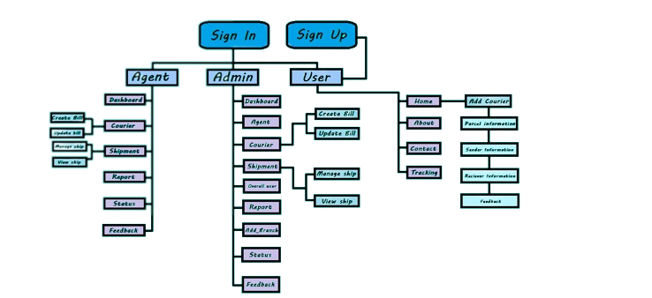

**FINISHED REPORT**

**DEVELOPER NAME**

USMAN AHMED (LEAD)

HAIDER FARAZ

SANA YOUSUF